MoTEVT-HPE CNET
LEARNING MODULE SPECIFICATION

Module title: CARRY OUT TECHNICAL SECURITY PROJECT

Module code: BIT0102

Date of last update: 30 January 2007

Level: Bachelor degree

Credit: 4

Access statement: Network Technology 1, 2 …..6 and TECHNICAL SECURITY

This module forms part of the mandatory modules for the Security Program.

Module introduction: Nowadays most information in the world is recorded in Information Systems that can be accessed across Internet and Local Area Networks. Bad hackers combine several techniques to penetrate unsecured networks to gather information or to cause damage to the system. To protect information systems against the ceaseless number of threats, vulnerabilities, DDOS attacks and malicious code proliferation we have to know how the attacker is performing his attack. To prevent against malicious hackers, you must think like a malicious hackers. As a result we suggest one of the best practices is penetration testing.

In this module students will apply there knowledge of Technical Security and they learn how penetration testing can be performed in an unsecured network.

During the course you will learn to set up different penetration tests and set up a testing plan. Moreover you will learn how to configure a specific network environment to be able to perform the test successfully. You will investigate is knowledge about testing tools.

Learning outcomes:

BIT0102.1: Describe the different penetration tests and the used test tools

BIT0102.2: Set up a Network Environment and perform the penetration tests

BIT0102.3: Investigate and select Software Packets for Firewall en IDS/IPS

What you need to produce (evidence requirements):

Prepare a portfolio containing

- Pre-investigations report
- Vulnerability matrix
- A test plan and set of test-cases
- Test report
- Network configuration manual for a secure network
- Software packet selection report for Firewalls and IDS/IPS

Module title: TECHNICAL SECURITY Project

Learning outcome:

What you need to do (performance requirements):

BIT0102.1: Describe the different penetration tests and the used testing tools

- Make a list of involved hardware (systems, switches etc.) and software (OS, server software, applications) and describe the weaknesses in these objects and weakness classes
- Select test topics and test tools to be used in testing
- Specify the goals of the test and the pre-conditions in the network environment to produce a successful test
- Formulate the relevant test-logging aspects

BIT0102.1: Set up a network environment and perform the penetration tests

- Set up a typical insecure network environment (see appendix 2)
- Schedule the different tests taking in account the different pre-conditions for configuration
- Set up a time table for testing
- Specify the network configuration and personal responsibilities
- Perform tests and report the test results
- Formulate recommendations for a secure network

BIT0102.3: Investigate and select Software Packets for Firewall en IDS/IPS

- Study the MS ISA-firewall and SNORT IDS-system
- Select other vendors of Firewall packets and IDS/IPS packets
- Compare different packets by price and specifications

What you need to know:

BIT0102.1: Describe the different penetration tests and the used testing tools

- System components
- Overview of specific test tools and how they can be used
- Weaknesses in hardware and software

BIT0102.2:

- System and network setup and configuration
- How the several test-cases are working actually and what is the kind of weakness the attack is exploiting

BIT0102.3:

- Specifications and proper working of ISA-server
- Specifications and proper working of SNORT IDS-system
- Packet selecting criteria

Purpose statement

The aim of this module is to give insight in the way weaknesses of information systems are exploited, the results of various attack that are performed and how to protect networks and information systems against intruders.

Notional design length

The notional design length of this module is 112 hours.

The notional design length to cover learning outcome

- BIT0102.1: is 50 hours
- BIT0102.2: is 40 hours
- BIT0102.3: is 22 hours

Content
- Audit and secure devices and media
- Audit and secure network topology
  - Create secure boundaries using firewalls, DMZs and proxy servers.
  - Create secure remote access.
  - Create secure wireless access.
  - Implement a segmented network.
  - Implement network traffic security protocols for sensitive network traffic.
  - Deploy network security technologies.
- Implement or harden intrusion prevention/detection systems
  - Assess security of current IDS/IPS system or evaluate need for implementing IDS/IPS system.
  - Assess and harden DMZ or evaluate need for implementing DMZ.
  - Assess and harden firewall or evaluate need for implementing additional firewalls.
  - Assess and harden routers, switches, and other network communication devices.
- Harden systems
  - Evaluate physical security and access control to critical servers.
  - Review and revise administrative accounts on infrastructure servers.
  - Implement strong authentication and password policies on all infrastructure devices.
  - Review, record, and update (as needed) operating system and application version levels.
  - Review current status of virus protection software installed on servers.
  - Assess and implement server, application, and client-side security technologies.
- Document all infrastructure changes.
  - Document changes to all infrastructure configuration settings.
  - Document changes to network topology, layout or structure.
  - Document changes to standard operating procedures.
  - Document changes to user policies and procedures.
- Perform compliance audit.

Suggested approaches to facilitate learning
Learning should be student-centred. Students can work in groups of 3 or 4 persons. A suggestion is to combine this module with the Technical Security Project (module code: BIT0101)

Assessment procedure
The assessor will examine all the documentation provided by you in your portfolio. The assessor may ask and record questions to confirm that the evidence is authentic and that all the evidence requirements have been met, particularly with regard to underpinning knowledge. The assessor may ask for a demonstration

Learning and teaching resources
-The following resources are to be considered to be standard:

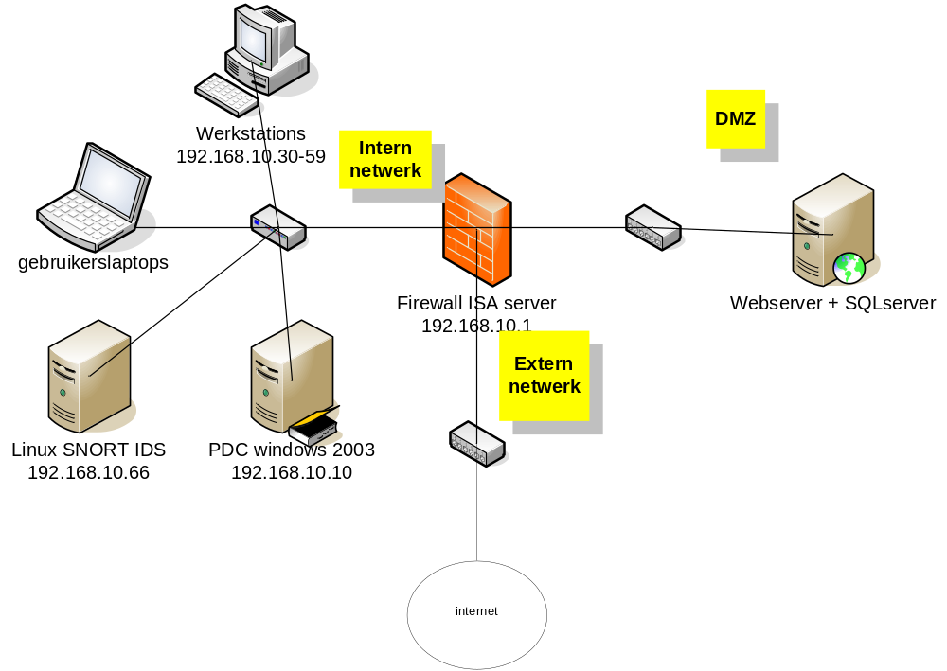

- Each learner will have access to computer facilities.
- Each learner/facilitator will have access to the relevant learning packs.

Prescribed textbooks

  - Whitaker and Newman (2006) - Penetration Testing and Network Defence. Indianapolis (USA): Cisco Systems, Inc..
  - McClure, Scambray and Kurtz (2006) - Hacking Exposed (5th ed.) New York (USA): McGraw and Hill
  - Forouzan (2006) - Data Communications and Networking (4th ed.) New York (USA): McGraw and Hill

- Computer software
  - MS ISA Firewall
  - SNORT IDS
  - MS SQL-Server

Appendix 1

vulnerability matrix

Technology | Type of technology | Software vulnerabilities | System management vulnerabilities  (bad practices) | Configuratie vulnerabilities (bad – or incomplete configutration) | Vulnerabilities by users

Appendix 2

Test-case format

Identification | Unique number for the test case
Testing goals
Test item | Main focus of the test
Expected testing time
Test logging aspects | Test performer | Name
 | Test system | Unique identification
 | Date
 | Starting time: | Ending time:
 | Testing time:
 | Testcase finished | Y/N
 | Incident introduced | Y/N
 | Change proposition introduced | Y/N
 | Testcase needs changes | Y/N
Pre-condititions | System and network configurations

